POST CERTIFICATION
We the following officers of Jonathan D. Rozier Katy, Post No. 164 The American Legion, hereby certify that the foregoing revised Constitution and By-Laws, after due notice was given to all members, was adopted at a regular meeting of this Post held on the _17_____th day of December 2024.

ATTESTED: ______________________________
POST JUDGE ADVOCATE

ATTESTED: ________________________________
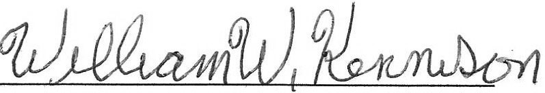
POST COMMANDER
ATTESTED:
POST ADJUTANT

DEPARTMENT CERTIFICATION

